Chapter 3 Plate Tectonic Review Questions

1. Pangaea is the theorized ____. Panthalassa is the theorized ____.
a. single continent hundreds of millions of years ago, single sea that surrounded it
b. single sea hundreds of millions of years ago, single continent that it surrounded
c. original northern continent, original southern continent
d. original southern continent, original northern Continent

2. If Wegener could have explained ____, his theory of continental drift might have been more widely accepted in his day.
a. why Australia has organisms like kangaroos
b. what causes the tides
c. how coal forms
d. what forces could move continents

3. A ____ is an underwater mountain range with a ____ running through the center of it.
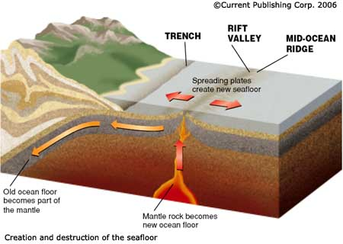
a. trench, rift valley
b. trench, mid-ocean ridge
c. rift valley, trench
d. mid-ocean ridge, rift valley

4. Mid-ocean ridges, rift valleys, and trenches are thought to
a. mark the boundaries between tectonic plates.
b. occur in the middle of tectonic plates.
c. have no relationship to plate tectonics.
d. reverse roles in the Southern Hemisphere.

5. According to the theory of plate tectonics, at a divergent boundary

a. plates spread apart from each other.
b. plates collide with each other.
c. plates slide past each other.
d. plates are stacked on top of each other

6. According to the theory of plate tectonics, at a convergent boundary

a. plates spread apart from each other.
b. plates collide with each other.
c. plates slide past each other.
d. plates are stacked on top of each other

