APES - Origins of Food Assignment
Name__________________________________
Store Name, Date, & Location _________________________________________________________________________________
Directions: Answer these questions by searching various products throughout the store, using your textbook, and the Internet. Anywhere you see a camera clip-art you must take a picture of you (selfie) in that area of the store. All SIX pictures must all be printed and handed-in with the answered questions. The pictures may all be on the same sheet of paper and in color OR black & white.

1. Fish: Locate one farm-raised species of fish. What are the advantages and disadvantages of raising fish this way?
Species: __________________________________________

Advantages | 1)
 | 2)
 | 3)
Disadvantages | 1)
 | 2)
 | 3)

Identify three ocean-caught varieties of fish and the method in which they were harvested (line-caught, net-caught, trawling, etc).

Species ______________________________________ Method __________________________________________
Species ______________________________________ Method __________________________________________
Species ______________________________________ Method __________________________________________

Which method of capture do you think causes the most environmental damage? Why?

2. Meat: There are at least 8 different terrestrial animals used for food in the world that you might be able to find in US markets. Identify all animals that you can find in the meat department.

Locate a meat product that is not raised conventionally (ex. Free-range chicken, grass-fed beef) and compare prices between this item and it conventionally raised counterpart.

Product ________________________________ NonConvential price________________ Conventional price________________

Why do you believe there is a cost difference?

3. Produce: Locate/Identify an organic fruit or vegetable. What agricultural techniques must be used or NOT used to certify a product as organic? Search the internet for your answer and cite the website you used.

Locate a fruit or vegetable that has both organic and conventionally grown varieties.
Product ______________________ Organic price________________ Conventional price ______________________
What percent more does the organic item cost? (Show your math calculation)

Many fruits and vegetables found in stores this time of year are out of season here but imported from other countries. Find five imported produce items and list their country of origin. Then locate each country on the world map that follows.
Food item | Country of Origin
1)
2)
3)
4)
5)
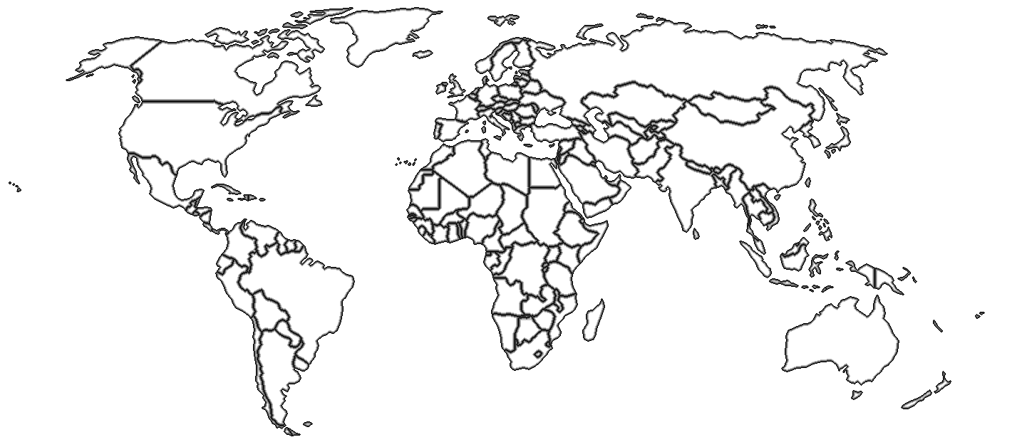
Which food traveled the farthest? _________________________Approximately how many miles? ________

How long do you think the food item needed to be in transit before it was put on the store shelf?

What techniques do you think might have been used to keep it from spoiling?

4. Processed food: Find a highly processed food item (Kid Cuisine TV dinner, frozen prepared food, Little Debbie snack cakes, etc.) and consider all the energy used to get this item from growing as several crops in different fields to your table for consumption. List all energy requiring steps from field to table.

Find a can of a vegetable. Vegetable_____________ Price__________ Ounces________ Price pre ounce__________

Find the fresh version of same vegetable. Price__________ Ounces________ Price pre ounce__________

Find a second highly processed food item and write down three additives or ingredients that you’ve never heard of (polysorbate 60, titanium dioxide, etc.).

Processed food: _________________________________________________________________________________
Additive or ingredient: _________________________________________________________________________
Additive or ingredient: _________________________________________________________________________
Additive or ingredient: _________________________________________________________________________

Research the additives on the internet and write down what they are used for in food and what other products besides food that you might find them in.
Additive | Purpose in Food | Non-food Uses
EX. Polysorbate 60 | Emulsifier: keeps fats from separating | Ingredient in hemorrhoid cream

5. Ethnic Food: Locate five foods in the ethnic section that have as their main ingredient something you have never eaten before and list the nutritional value (percentage) for each.
Food | Protein % | Carbohydrate % | Fat %

Are any if these foods particularly high in protein?

6. High Fructose Corn Syrup: Many foods you would never expect contain High Fructose Corn Syrup. List 10 items that contain High Fructose Corn Syrup but are not products that are meant to be sweet (soda, cake, cookies, etc.).
***Extra credit for the most original answer in the class – based on MY opinion***
Brand Name (example: Heinz) | Product (example: ketchup)
1)
2)
3)
4)
5)
6)
7)
8)
9)
10)

7. Meal planning: Minimum wage in Florida is $8.05 per hour in 2015. A person who works full time, 40 hours per week, makes $322 a week. Generally, you should spend 10% of your income on food. This would leave a person with approximately $4.60 a day for food. I will more than double that. Your job is to plan a day’s worth of 3 healthy meals, snacks, and beverages for $10.

Breakfast: food and price for a serving:

Your total cost for a day’s food:

Lunch: food and price for a serving:

Dinner: food and price for a serving:

Snacks/drinks: food and price for a serving:

Reflection: This must be done on your own, by each student

What did you learn by doing this activity? If your answer is “nothing”, you fail.

